**Password reset Flow – front end validation.**

Landing to home page where you can proceed with forgot password flow.

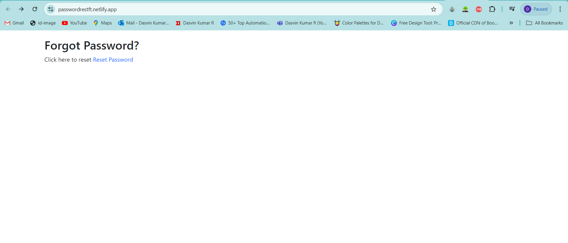

Forgot password page.

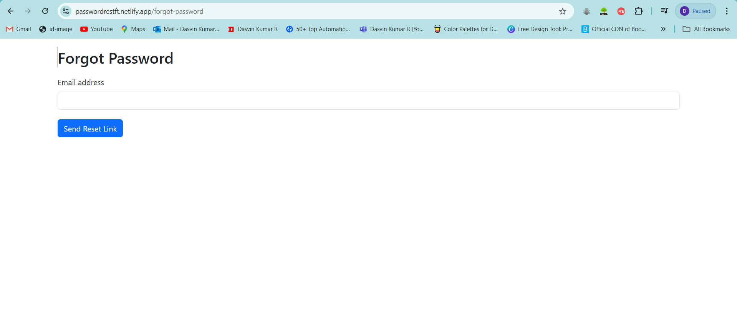

Entering wrong mail and checking for error throw.

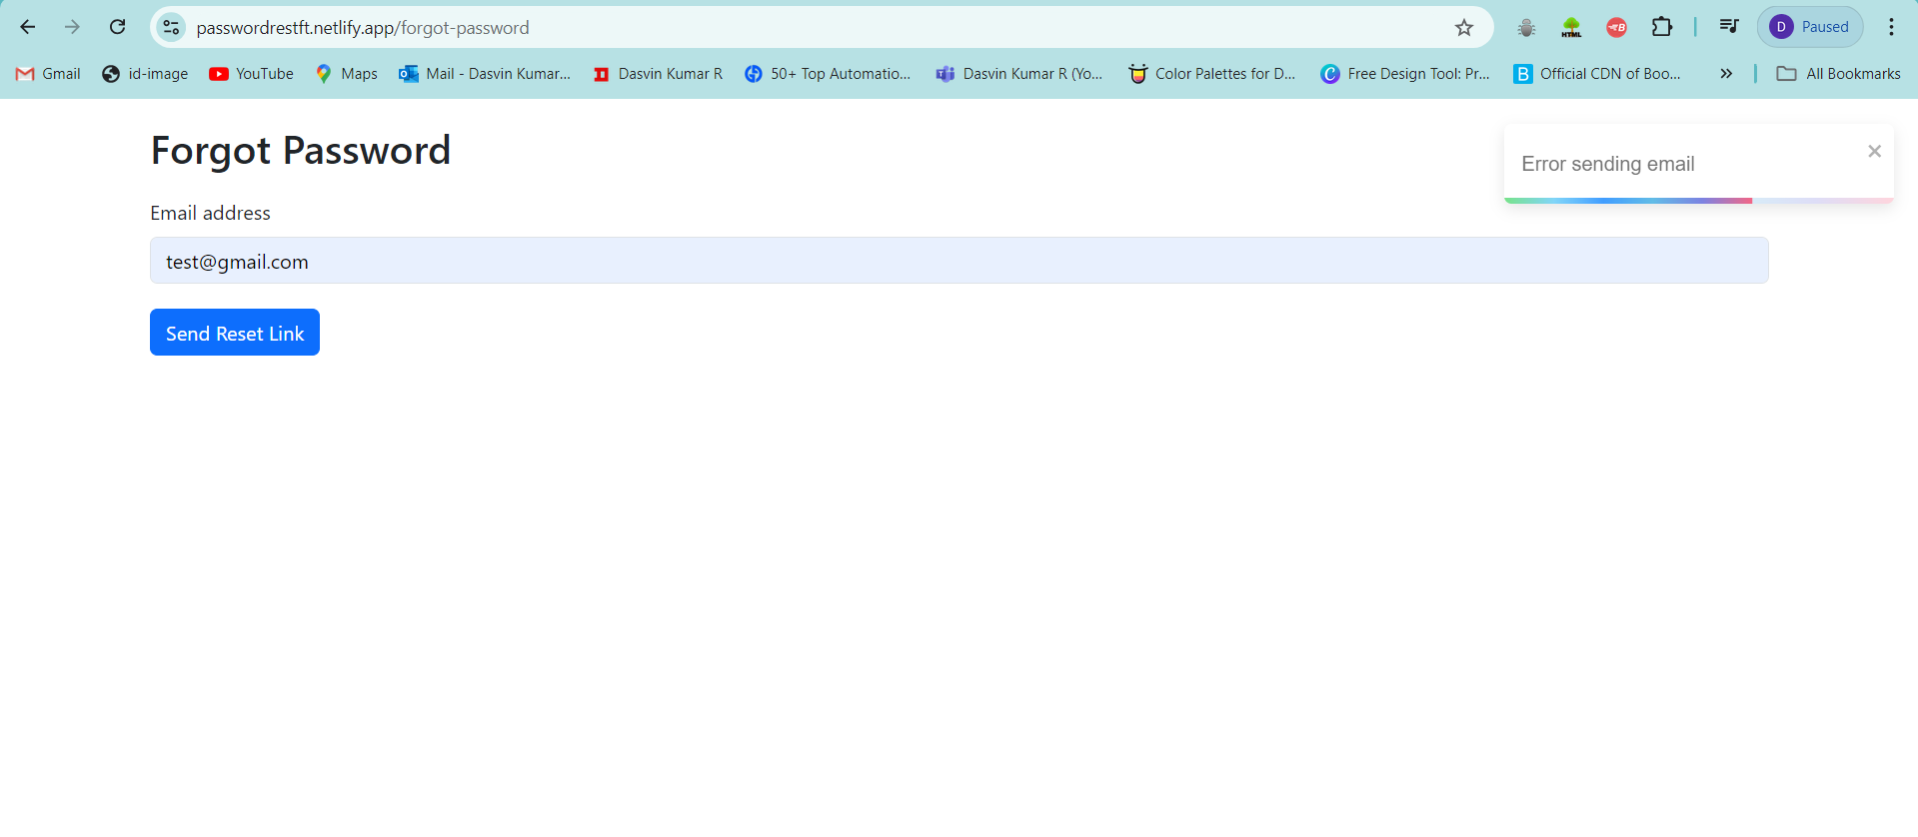

Validate password rest link is sent to email that matches DB.

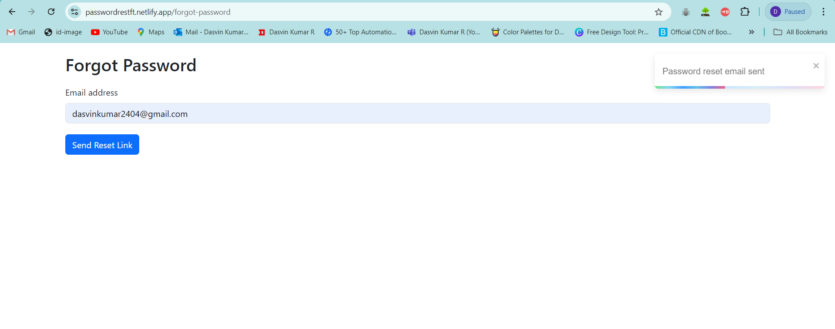

DB check.

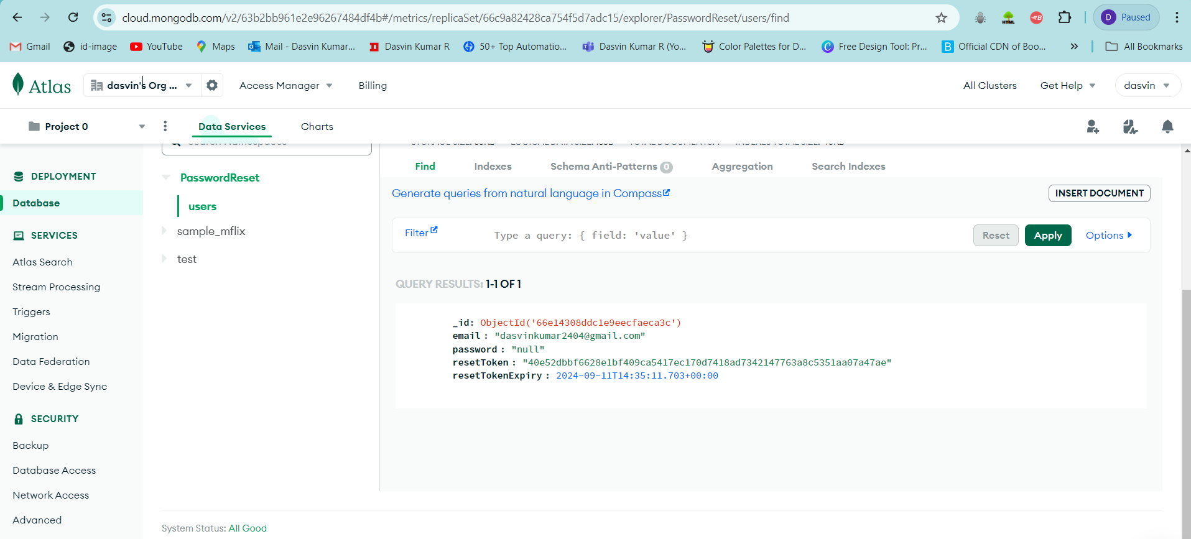

Validate password reset mail send successfully.

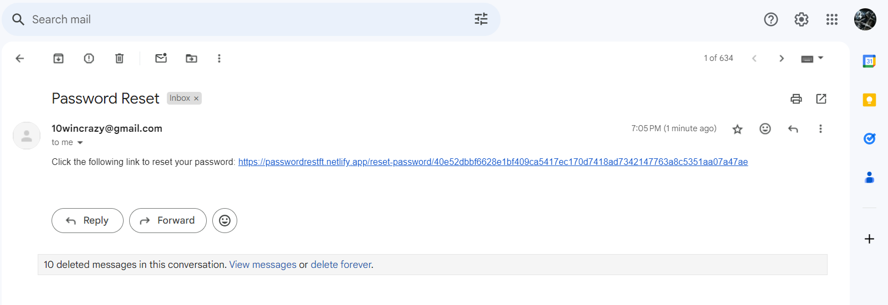

Validate password reset page opened and password is changed successfully.

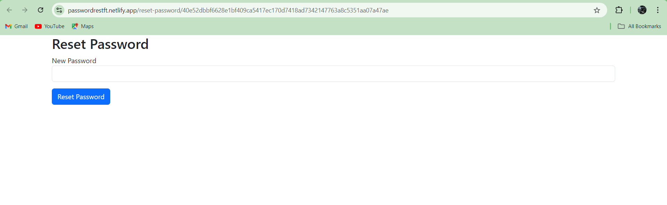

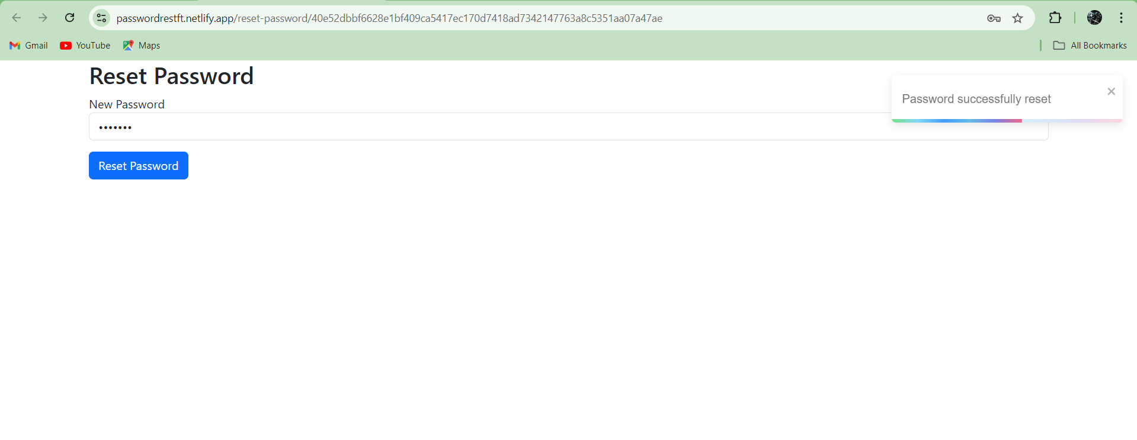

DB check for updated password.

